# 1. Conceptual Design (ERD’s) REVISON week 1

## Revision Test 1

1. What is an entity?

a) an object b) an array c) an class

2. What is appropriate entity naming

a) in singular form b) in plural form

3. Which of the following is not an entity?

a) Student b) Priestley c) Computer d) student_phone_number

4. Which of the following is not an attribute? TRICKY ONE!

a) venue ? could be both attr./occur.

b) car c) picture_name c) date

5. Which of the following is an attribute of an entity type Customer?

a) customer_name b) customer_email c) order_date d)delivery_date

6. Which of the following is an appropriate identifying attribute?

a) customer_name b) customer_email c) customer_id

7. Which of the following statements is correct?

1. an entity can have only one occurrence
2. an entity must have more than ONE occurrences

8. When identifying an entity type in the text you look for

1. verb b) noun c) adjective

9. Which of the following below is not an occurrence?

a) Sanela Lazarevski b) Venue c) 22222 d) Booking

10. When drawing an ERD you should immediately identify cardinality of the relationships?

a) True b) False

11. When deciding the cardinality you base it on the information in the text.

a) True b) False

12. Relationships don’t have a name.

a) True b) False

13. Choose cardinalities that can be defined on the relationship.

a) one to many b) one to one c) many to many d) many to one

a) 1:M b) 1:1 c) M:N d) M:1

**Task 2:**

Below are given entity names, attributes and occurrences. Your task is to complete the table below, and specify if given names are attributes, identifiers and/or an entity name. If it’s an occurrence, only highlight it on the list with a note, it’s occurrence for which attribute.

These attributes, entities, and occurrences described as a part of sales department database design record’s for full time and part time sales staff, who work on shifts. Each member of staff is expected to attend an induction course such as First Aid and many other relevant courses. All sales staff has to have a driving licence, and each full time sales is assigned a car. Each department has number of jobs to be allocated to staff.

Work in pairs. You’ve got 15min for this task. When you finish exchange your work in class to mark each others work any. Good luck! I am sure you will enjoy this tutorial.

|  |  |  |  |  |  |  |  |  |
| --- | --- | --- | --- | --- | --- | --- | --- | --- |
| ~~MOT_expiry~~ | | ~~date_of_birth~~ | vehicle | ~~make~~ | ~~reg_no~~ | F654DWR |  |  |
|  | employee |  | | ~~model~~ |  | citroen |  |  |
| ~~forename~~ | |  | ~~standby~~ |  | shift |  | ~~Shift_date~~ |  |
| ~~surname~~ | | ~~address_line1~~ | |  | job |  |  |  |
|  | dept | ~~address_line2~~ | | ~~hours~~ |  |  | ~~gender~~ |  |
| First Aid |  | tel_moblile | ~~course~~ | ~~rota~~ |  |  |  |  |
| ~~job_id~~ |  | ~~date_completed~~ |  | ~~day~~ |  | ~~ethnic_group~~ | |  |
| ~~job_description~~ | ~~course_name~~ | | ~~Course_id~~ |  |  | ~~registered_disabled~~ | | |
| Transport | Induction | ~~Employee_id~~ | | ~~dept_name~~ | ~~dept_id~~ |  |  |  |

1. List your Entities and Attributes in the table:

(Occurrences not specified in table, these should be used as reference for the relationships for task 2):

|  |  |  |  |  |  |  |  |  |  |  |
| --- | --- | --- | --- | --- | --- | --- | --- | --- | --- | --- |
| **Entity Name** | **Identifier** | **Attribute** | **Attribute** | **Attribute** | **Attribute** | **Attribute** | **Attribute** | **Attribute** | **Attribute** | **Attribute** |
| *COURSE* | *Course_id* | *Course_name* | *Date_completed* |  |  |  |  |  |  |  |
| VEHICLE | Reg_no | Make | Model | Mot expiry |  |  |  |  |  |  |
| JOB | Job_id | Job description |  |  |  |  |  |  |  |  |
| SHIFT |  | Rota | Day | Hours | Shift_date |  |  |  |  |  |
| DEPT | Dept_id | Dept_name |  |  |  |  |  |  |  |  |
| EMPLOYEE | Employee id | Forename | Surname | Standby | Address line1 | Address line 2 | DOB | gender | Ethnic grp | Reg disability |

1. Draw your ERD below, and specify your assumptions and 4 validation questions for your ERD:

(Example of a validation question: *Which shifts did John Campbell work on in the past two months?* To be able to answer this question we will need entities employee and shift, which would hold attributes such as employee name, shift, and date)



Produce an ERM for each of the following situations. On the ERD diagram be sure to label and identify the cardinality and optionality of each relationship.

# Task 2a:

In a group medical practice each doctor has many patients registered but a patient can only register with one doctor. Doctors may exist within the group that have no registered patients e.g. if they are involved only in research, but each patient must be registered with a doctor.

Step 1: Underline all nouns in the text above and list them below:

Medical practice,

doctor,

patients,

group,

research

Step 2: Ask yourself, is your noun

* an attribute of an entity, or research with occurrences YES/NO, or
* an occurrence of an attribute or - research of attribute OTHER
* an entity, which would have more than ONE occurrences and it is relevant to our system

medical practice will have only one value – NO

doctor, - YES

patients, - YES

Step 3: List below your entities and check your final list with your tutor

doctor, - YES

patients, - YES

Step 4: For each entity create a table defining attributes and occurrences

Example: DOCTOR

|  |  |  |  |  |  |
| --- | --- | --- | --- | --- | --- |
| attributesName | Doctor_id | Name | Address | Phone | Reseach |
| Occurrences | DR222 | JGrogan | East Leeds | 0113 222 2222 | Yes |
| Occurrences | DR555 | PSmith | North Leeds | 0113 444 4444 | No |
|  |  |  |  |  |  |

Example: PATIENT

|  |  |  |  |  |
| --- | --- | --- | --- | --- |
| attributesName | Patient_id | Name | Address | Phone |
| Occurrences | P1111 | HSmith | East Leeds | 0113 111 1111 |
| Occurrences | P2222 | SCarvill | East Leeds | 0113 333 3333 |
| Occurrences | P3333 | HGould | South Leeds | 0113 222 3333 |
| Occurrences | P4444 | JCampbell | North Leeds | 0113 555 3333 |
| Occurrences | P5555 | HCampbell | North Leeds | 0113 555 3333 |

Step 5: Draw your ERD, by defining entities, relationships, relationship names cardinality.



[How would your ERD change if past registrations are included?]



# Task 3b:

drop table doctor cascade constraint;

drop table patient cascade constraint;

create table doctor (

doctor_id NUMBER(2) PRIMARY KEY,

name VARCHAR2(25),

phone VARCHAR2(25),

research VARCHAR2(3));

create table patient (

patient_id NUMBER(2) PRIMARY KEY,

name VARCHAR2(25),

phone VARCHAR2(25),

address VARCHAR2(30),

doctor_id NUMBER(2) references doctor(doctor_id));

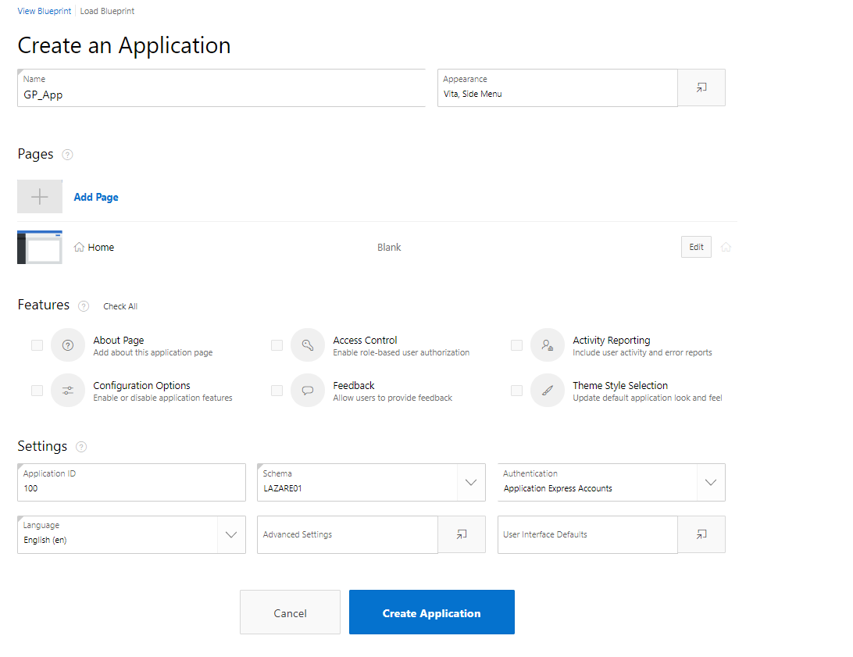

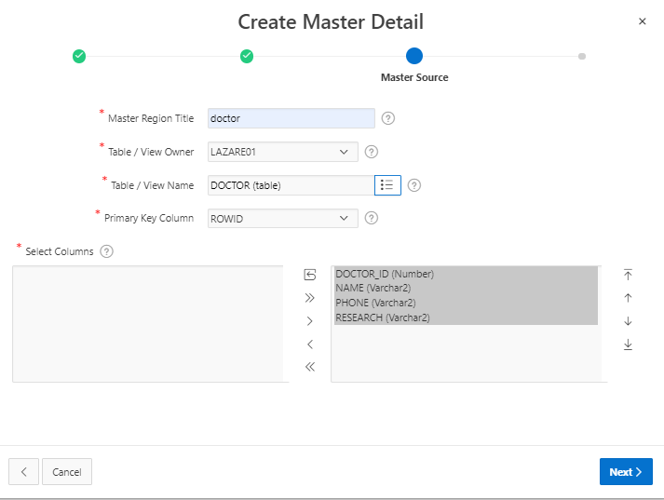

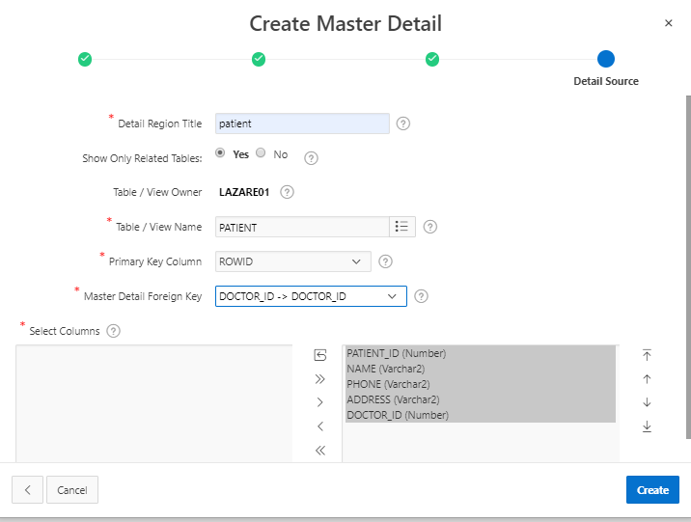

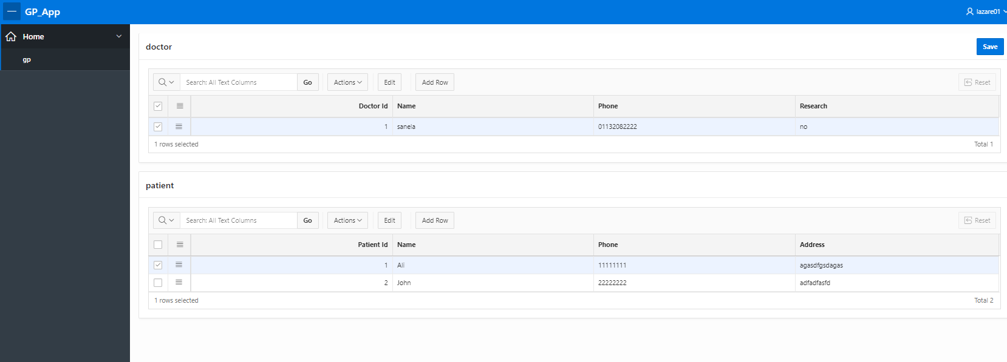

NEW FORM side by side type

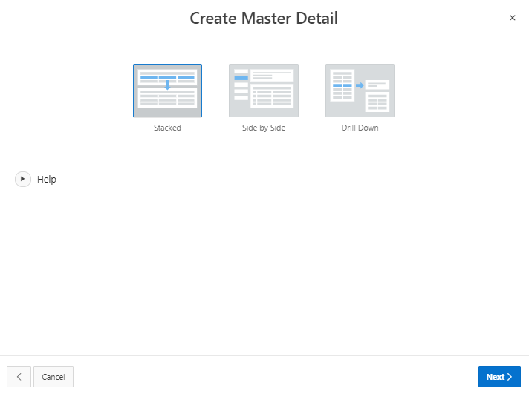

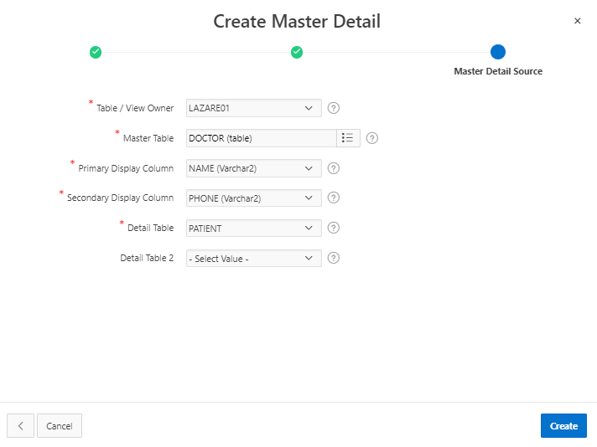

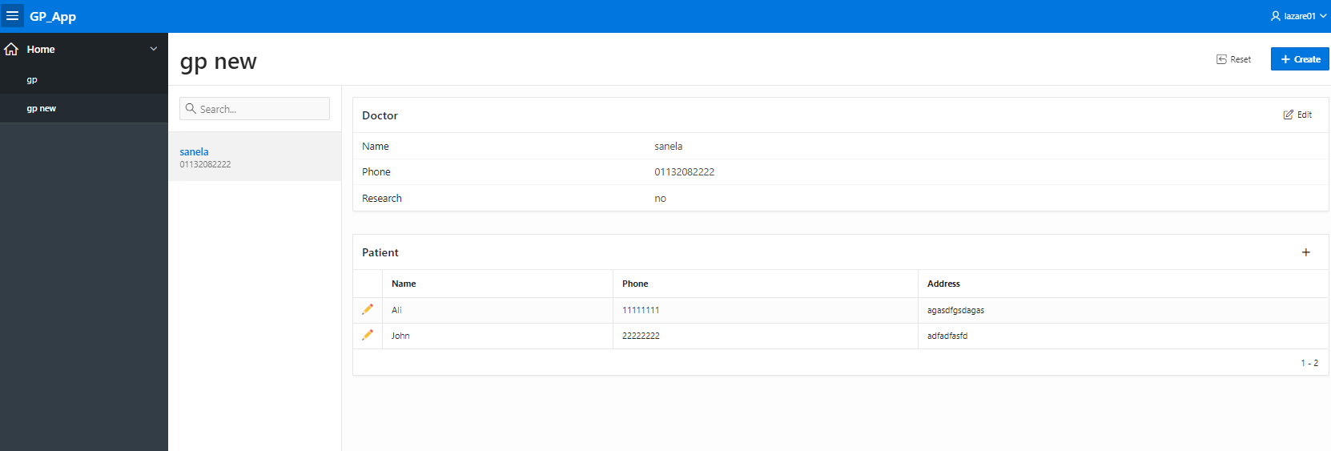

Click save

Now check data in OB

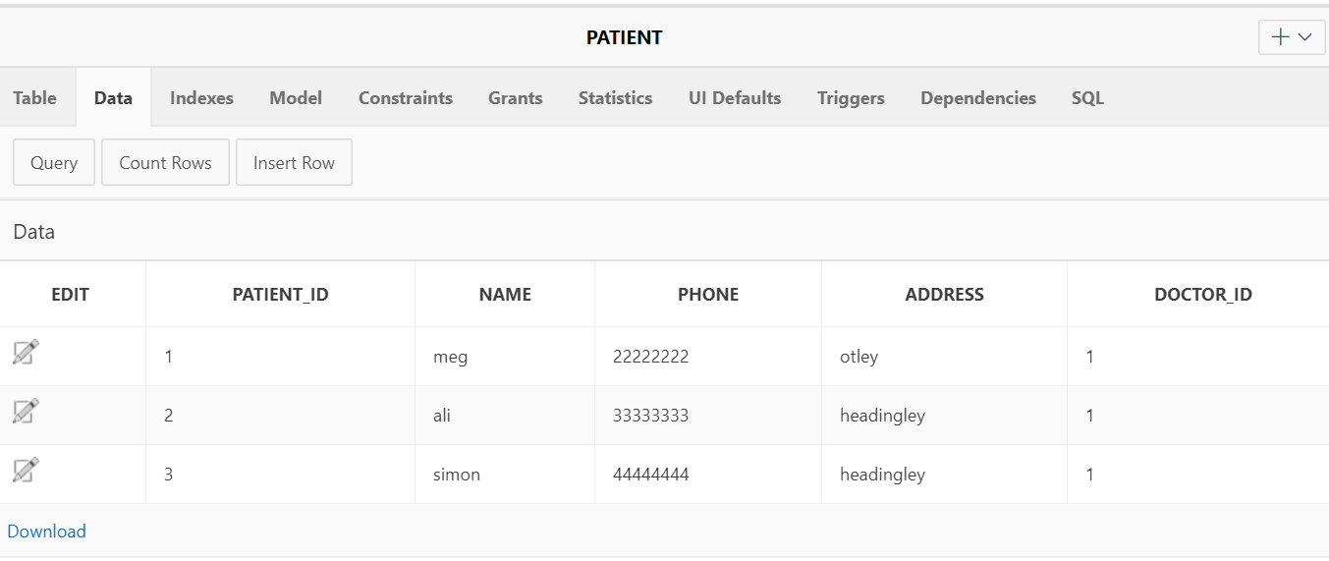

Create a repot for doctors and patients:

select * from doctor d, patient p where d.doctor_id = p.doctor_id;

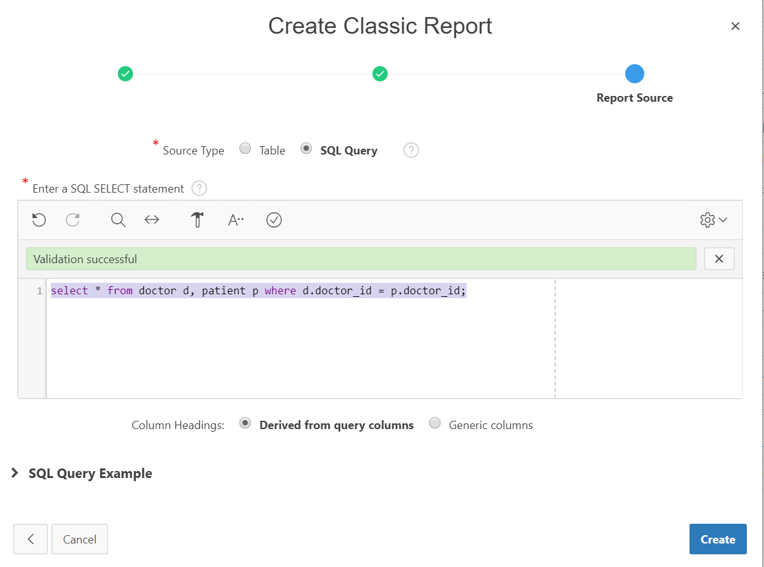

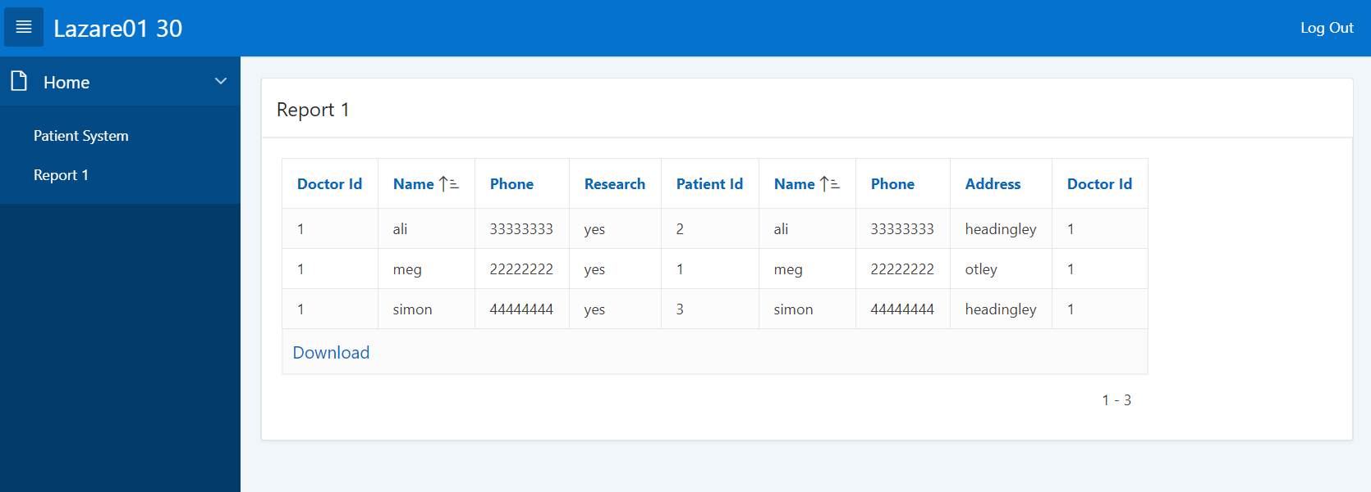

**Task 3: Derive the model above to define your RDM solution.**

Task(Task_id, Task_Name,…

Project( Project_id, Project_StartDate, Project_EndDate,…

Project_Task(PT_id, *Project_id* Desc,… *Task_id,*

Consultant(Consultant_id, Name, Address, Phone,…

Client( Client_id, Name, Address, Phone,…

Appointment(Appointment_ref, *Client_id, Consultant_id,* Date, Location,…

* Appointment (appointment_ref may not be needed) .. a more natural option for the compound key would have been date and time .. you may choose to make this change. However, when you start your implementation, you will find implementation easier if you have appointment ref no, that will always be unique. That is often referred as a surrogate key, normally defined at the implementation stage.

**New Relation/Table based on 0 or 1 : M cardinality**

ConsultantTask(*PT_id, Project_id ,* *Consultant_id,*